**Excel 2013 error when opening file from windows:**

“**There was a problem sending the command to the program**”

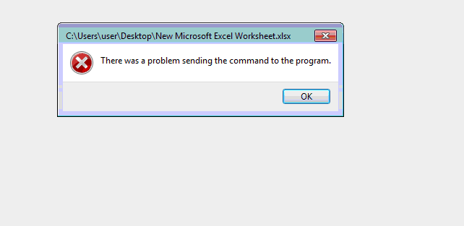

Open **RUN** and type in **regedit**

*Make a backup of the registry*

Under **HKEY_CLASSES_ROOT**

To allow file to open in EXCEL modify the following keys:

**HKEY_CLASSES_ROOT\Excel.Sheet*\Open\Command**\ from

**"C:\Program Files\Microsoft Office\Office15\EXCEL.EXE" /dde** <to> **/e "%1"**

To remove error box do the following:

Delete **ddeexec** key